Embargoed until Thursday, April 28th, 12:01AM

TO: Interested Parties
FROM: Shira Angert, Benenson Strategy Group
RE: The Intersection of Gun Violence, Policing and Mass Incarceration in Communities of Color: Research Results
DATE: April 28, 2016

Methodology
Benenson Strategy Group conducted 1200 telephone interviews, 600 among African Americans and 600 among Hispanics nationally, including an oversample of 18-29 year olds, from February 22-28, 2016 as part of the Engaging Communities in Reducing Gun Violence project with the Joint Center for Political and Economic Studies, the Joyce Foundation, and The Urban Institute. All respondents were registered voters who are likely to vote in the 2016 presidential election. The margin of error for each group (African Americans and Hispanics) is ±3.94% at the 95% confidence level. It is higher among subgroups.

Communities of color see gun violence, mass incarceration and police misconduct as serious problems that personally affect their lives

- In communities of color, gun violence, police misconduct and incarceration are viewed as extremely serious problems.

Extremely Serious Problem (5 on a 5-point scale)
 | African Americans | Hispanics
Gun violence | 80% | 54%
The incarceration rate | 69% | 43%
Police misconduct | 50% | 24%

- Despite being viewed as an extremely serious problem, a majority of African Americans believe that most Americans don’t care about gun violence that affects communities of color.
  - 57% of African Americans agree that “most people in America don’t care about the gun violence that is affecting communities of color,” a feeling that is particularly pronounced among young people, with 64% of African Americans aged 18-29 agreeing.
    - Hispanics are less inclined to agree with the statement with only 45% agreeing and 48% of Hispanics aged 18-29.

- Not only are these problems viewed as serious, but they’re personal for African Americans and Hispanics, as many have been personally affected by gun violence, incarceration or negative interactions with law enforcement.

Personal Experiences
 | African Americans |  |  | Hispanics
 | All | 18-29 yrs | All |  | 18-29 yrs
Personally know someone who has been sent to jail, prison, or another type of correctional facility | 75% | 73% | 58% |  | 59%
They, or someone close to them, have had a negative interaction with law enforcement | 56% | 62% | 34% |  | 40%
They, or someone close to them, have been affected by gun violence | 42% | 48% | 29% |  | 26%

Communities of color have complex and nuanced views on policing

- When it comes to policing, opinions are mixed among communities of color.
  - On the one hand, 82% of African Americans and 65% of Hispanics agree that they “frequently worry about interactions between the police and young men of color.”
  - But at the same time, there is still a sense that police help keep communities safe: 62% of African Americans and 80% of Hispanics say that the police make their communities safer.
  - Additionally, when forced to choose between two options, an overwhelming majority of African Americans and Hispanics, including young people, don’t believe racism is pervasive within police departments.

Which statement do you agree with more?
 | African Americans |  |  | Hispanics
 | All | 18-29 yrs | All |  | 18-29 yrs
Most police officers in America are professionals and do the right thing, but there are a few bad apples who discriminate and profile on the basis of race. | 74% | 71% | 83% |  | 82%
Most police officers in America discriminate and profile on the basis of race. | 23% | 27% | 15% |  | 16%

Gun violence, police misconduct, and mass incarceration are viewed as interconnected issues among communities of color

- These three important issues—gun violence, police misconduct and mass incarceration—are not viewed in silos within the African American and Hispanic communities, but rather, they’re viewed as interconnected issues that have a direct effect on each other.
  - For example, a strong majority believe the incarceration rate can be reduced by keeping guns out of the wrong hands and that fewer guns on the street would improve police-community relations.

Attitude Statements: % who agree
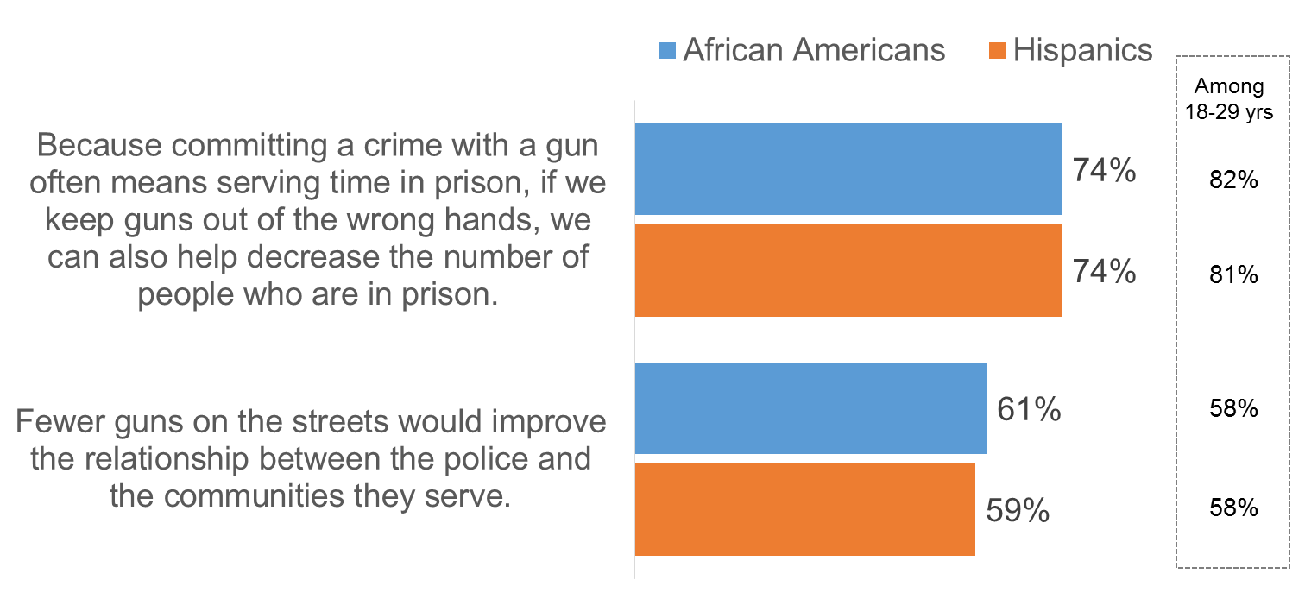

- Additionally, there is little concern that new gun laws would raise incarceration rates.
  - Most African Americans (56%) and Hispanics (70%) disagree that “passing new gun laws will only lead to more people of color being sent to prison and will do little to reduce gun violence.”
    - 64% of African Americans aged 18-29 disagree, as do 73% of Hispanics aged 18-29.

- Consequently, there is a strong sense among communities of color that we need to address the issue of gun violence.
  - 84% of African Americans and 95% of Hispanics agree “the most important thing we can do to reduce gun violence is to make sure we keep guns out of the wrong hands.”

There is strong support for a broad range
of solutions to address these problems

- Given the urgency and desire to solve some of these major problems, policy ideas about preventing gun violence and improving police accountability receive wide and intense support.
  - In particular, proposals for universal background checks, re-entry support for returning citizens, and community investments to reduce gun violence rise to the top.
  - Lost or stolen gun notifications and cracking down on illegal gun traffickers also receive strong support.

Policy Proposals: % Strongly Support
 | African Americans | Hispanics
Background Checks  Require everyone to pass a background check before buying a gun, no matter where they buy it, including online gun sales, private gun sales and sales at gun shows. | 87% | 90%
Increase Investment in Returning Citizens  Increase funding for job training, life skills support, and mental health and drug abuse counseling for people returning to the community after they’ve served their time in prison. | 83% | 68%
Reduce Gun Crime by Investing in the Community  Reduce the likelihood of gun violence by addressing the root causes of crime by investing in community programs including job training, mental health services and programs specifically for young people. | 82% | 78%
Increased Accountability for Police  Strengthen accountability for police officers by implementing civilian review boards, body cameras for police officers, and the ability for police chiefs to fire officers who repeatedly exhibit racial bias. | 80% | 74%
Lost/Stolen Gun Notification Requirement  Require individuals to notify law enforcement if their gun is lost or stolen to crack down on the amount of illegal guns on our streets. | 80% | 70%
Crack Down on Gun Traffickers  Create stiffer penalties for people who sell guns illegally to keep guns off our streets. | 79% | 74%

*Total support (very + somewhat support) for these proposals among African Americans and Hispanics averages to 91% and 92% respectively.
- However, support for new gun laws does not mean African Americans and Hispanics want to take guns away from law-abiding citizens.
  - In fact, communities of color believe that a gun in the home is much more likely to be used to protect, rather than harm, members of the household.
  - Notably, in our survey, 28% of African Americans and 30% Hispanics report living in a household where a gun is owned.

If there is a gun in the home, what do you think is more likely?
 | African Americans | Hispanics
The gun being used to protect members of the home | 75% | 73%
The gun being used to harm someone in the home, either accidentally or on purpose | 18% | 22%

- Nonetheless, the belief that guns are more likely to be used to protect rather than harm someone in the household does not preclude communities of color from strongly supporting important policy ideas to strengthen gun laws, reduce gun violence and improve police accountability.

- It is clear from this data that communities of color see gun violence as an extremely important issue, one that they feel on a deeply personal level, and one that is tied to other issues affecting their communities – namely, incarceration and relations with police. There is a desire for action on these issues, and they support a range of commonsense proposals to address them in America today.

